**Start**

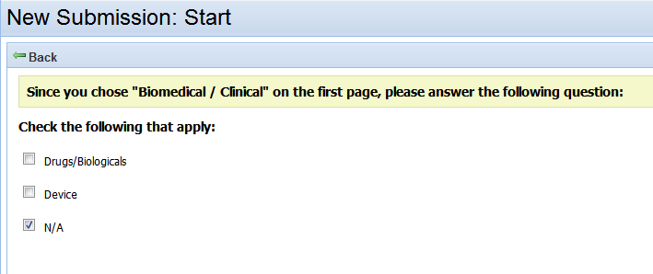

Help Text:

Includes both investigational and FDA-approved drugs/biologicals and devices, for approved and non-approved uses.

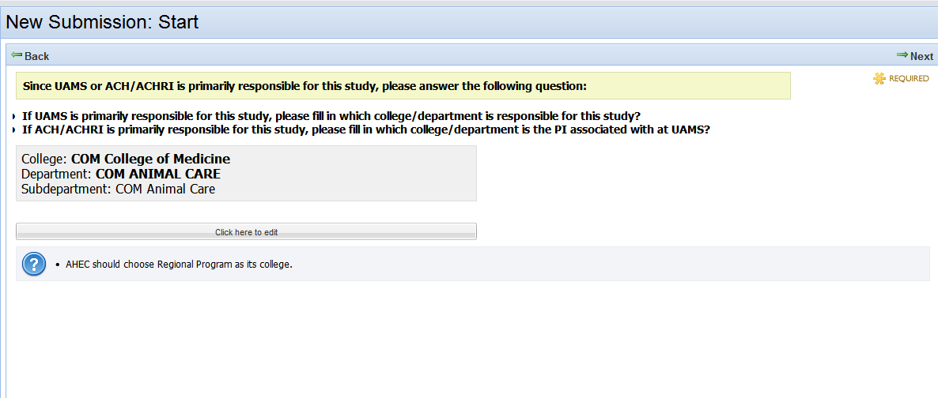

Edit:

If UAMS is primarily responsible for the study, please select the responsible UAMS college/department.

If ACH/ACHRI is primarily responsible for the study, please select the UAMS college/department that the PI is associated with.